Ben-Shahar’s Happiness Model
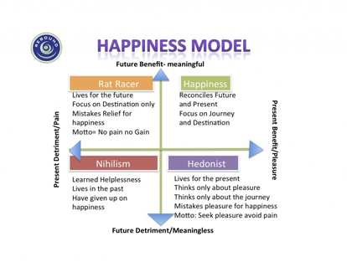
The Happiness Model defines four happiness archetypes as follows: 1. Nihilism – Nihilists have lost the joy in life. They derive no present pleasure in their work or life, and expect no future benefits or rewards. They’ve “given up.” 2. Hedonism – Hedonists live for the moment. They pursue pleasure and an easy life, and give little or no thought to future consequences and plans. 3. Rat Racing – The Rat Race archetype often sacrifices current pleasures and benefits in anticipation of some future reward. 4. Happiness – True happiness is achieved when there is a perfect balance between present pleasure and future benefits. The benefits are meaningful and match a person’s beliefs, and values.

For trainers it is useful to help trainees explore what their future “happy” goal is and that the happiness is aligned to their core values. Then the goals have true meaning and the journey to reach them is optimistic and pleasurable. And perhaps also take a moment to ensure their own goals and work life balance are properly aligned.

